**LAB 6**

**Task 1:** **Setting up network.**

1. **VPN Server is communicated by Host U:**

1. **Host V communicates with VPN Server:**

1. **Communication between Host U & V doesn’t take place.**

1. **By showing captured packets, run tcpdump on the router and sniff the traffic on each of the network.**

* **Sniffing packets on eth0 interface.**

* **Sniffing packets on eth1 interface.**

* VPN Server can talk with Host U, and Host V can communicate with VPN Server.
* Host U should be able to communicate with Host V but not the other way around.
* Sniff the traffic on each network segment using tcpdump on the router. Demonstrate your ability to capture packets.

**Task 2: Create and Configure TUN Interface.**

**Task 2.a: Name of the Interface**

* Changed to “singh0”

**Task 2.b: Set up the TUN Interface**

* Run the "ip address" command one more after you've completed the previous two instructions.

* When compared after assigning the ip address:

**Task 2.c: Read from the TUN Interface**

**Task 2.d: Write to the TUN Interface**

* **Spoofed ICMP reply:**

**Task 3: Send the IP Packet to VPN Server Through a Tunnel**

* Inside UDP Packet
* Proofs to demonstrate that when you ping an IP address in the 192.168.53.5/24 network, the ICMP packets are received by tun_server.py through the tunnel.

**Task 4: Set Up the VPN Server**

**Task 5: Handling Traffic in Both Directions**

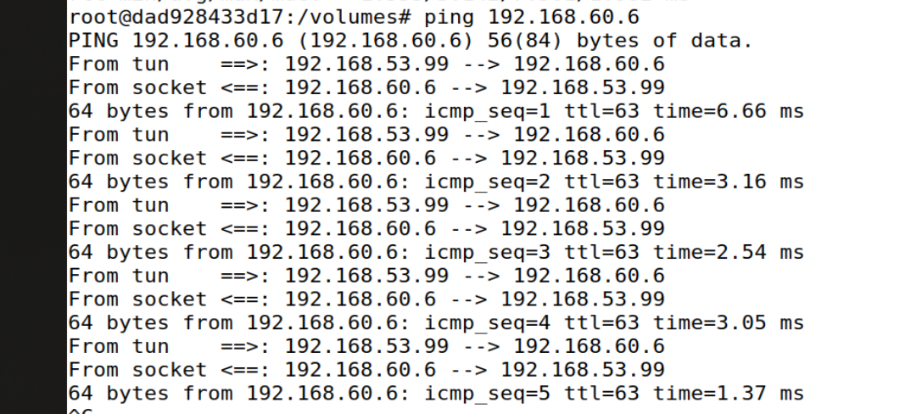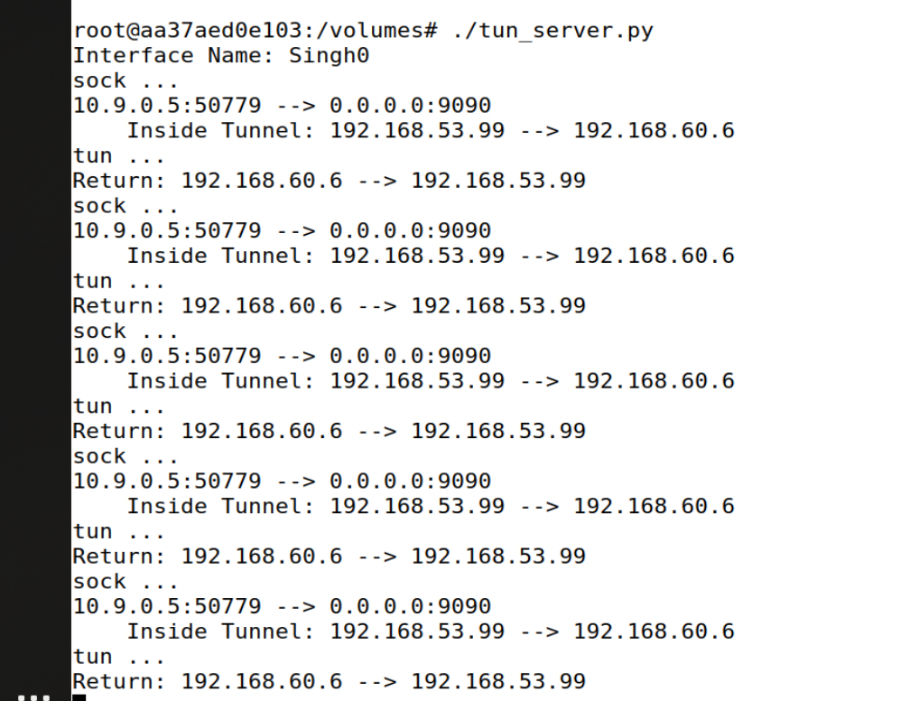

**Task 6: Tunnel-Breaking Experiment**

* tun server.py has been stopped. The connection had been broken. The cursor came to a halt, and I was unable to enter anything.

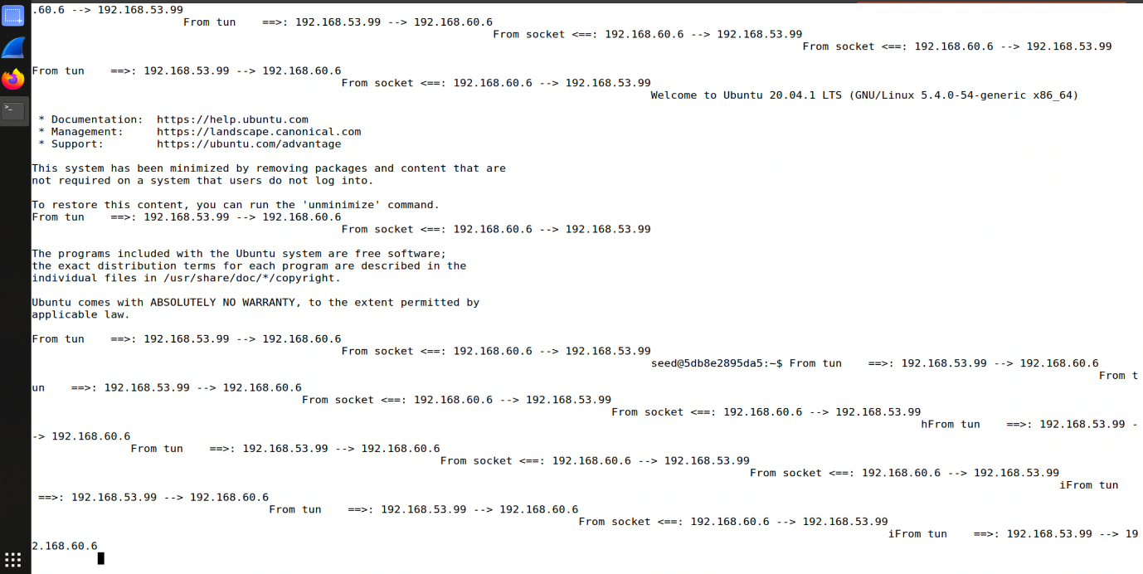

**Task 7: Routing Experiment on Host V**

# ip route del default / Delete the default entry

/ # ip route add 192.168.53.99/24

